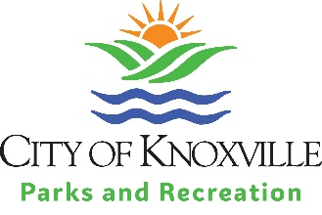
Knoxville Neighborhoods
Hosting Neighborhood Events at City Parks & Facilities
Neighborhood Associations in good standing with the City’s Office of Neighborhoods are invited to use City parks and facilities for meetings and events.
Scheduling an event in advance is very important as some sites may already be reserved. Please schedule your event in advance using the following steps:
STEPS TO SCHEDULE YOUR SPECIAL EVENT
- Submit Special Event Application [PDF] to Elaine Frank in the Office of Special Events or complete Online Special Event Application Form
- Review Insurance Requirements for Special Events at City Parks & Recreation Facilities [PDF].
- Submit Certificate of Insurance before event (if required)
- Depending on type of event, additional steps may be required
  - Community / Neighborhood Event or Festival [PDF]
More Details about Fees & Insurance
- Fees for Use
  - Picnic Shelters, Gazebos – No charge
  - Rec Centers/Facilities
    - During operating hours – Normally free
    - After operating hours – Reduced fee for meetings & events
- Insurance – required by City Risk Management except for the following:
  - Club meetings and organizational meetings
  - Celebrations (anniversary parties, birthdays, banquets, luncheons, awards ceremonies)
  - Meetings of a social, academic, business or philosophical nature or expressive activity (other than fundraising)
(NOTE – Any event with an inflatable must have insurance & sign disclosure form)
For more information, please contact:
Office of Special Events – Elaine Frank – 865-215-4248 efrank@knoxvilletn.gov
Parks & Recreation – Jamie Simerly – 865-215-1733 jsimerly@knoxvilletn.gov

